

Lab 3: MEMS Accelerometer, Timer and Interrupts

ECSE 426 – Microprocessor Systems



McGill University

Winter 2015

Group 4: Sidney Ng 260507001

Meng Yin Tao 260480207

Due March 16th 2015

Contents

List of Figures 2

List of Tables 2

1. Abstract 3

2. Problem Statement 3

3. Theory and Hypothesis 3

3.1. Accelerometer 3

3.1.1. Orientation 3

3.1.2. Acceleration 3

3.2. Data Calibration and Filtering 4

3.2.1. Data Calibration 4

3.2.2. Data Filtering 4

3.2.3. Data Interpretation 4

3.3. External Keypad 4

3.3.1. Circuit Layout 4

3.3.2. Data Acquisition 5

3.3.3. Handling Key Bouncing 5

3.4. External 7-Segment Display 5

3.4.1. Circuit Layout 5

3.4.2. Data Display 6

3.5. Timing 6

3.5.1. Timing Based on Sample Rate 6

3.5.2. Timing Based on Hardware Timer 6

4. Implementation 7

4.1. Component Configuration and Initialization 7

4.1.1. GPIO Configuration 7

4.1.2. Accelerometer Configuration, Accelerometer Interrupt and Interrupt Handler 7

4.1.3. Timer Configuration, Timer Interrupt and Interrupt Handler 7

4.2. Collect User Input 7

4.2.1. Initialize Keypad 7

4.2.2. Return User Input 7

4.2.3. Improvement on Keypad 7

4.3. Data Sampling 7

4.4. Data Processing 7

4.5. Data Comparison 7

4.6. Result Display 8

4.6.1. Visual Feedback 8

4.6.2. Display Current Angle 8

4.7 Continuous Process 8

5. Testing and Observation 8

5.1. Accelerometer Calibration 8

5.2. Kalman Filter 8

6. Conclusion 8

Reference 8

Appendix A – Calibration Data 9

# List of Figures

Figure 1: Board Axes and Tilt 3

Figure 2: Keypad Layout 4

# List of Tables

# 1. Abstract

# 2. Problem Statement

The goal of this experiment is to create a system that detects the orientation of the STM32F4 discovery board. The rotation of the board around its axes is detected using the built-in accelerometer. However, the accelerometer cannot determine the yaw (rotation around the board’s z-axis) since it does not result in a change in acceleration. Only the roll (rotation around the board’s x-axis) and pitch (rotation around the board’s y-axis) can be found using the accelerometer. When the accelerometer’s raw data becomes available, the processor will calibrate it using a pre-built calibration matrix and filter it using a Kalman filter whose parameters are experimentally defined. In order to make sense of the data, it needs to be converted into an angle in degrees. This conversion is done using the arctan function available in the math library. Once the angle is available, it can be compared against the user input. The user is prompt to enter a target angle for both the roll and the pitch using a 4x4 external keypad. As the user tilts the board, an animated indication on the 7-segment display will help the user directing the board toward the target angle. Once the user is within five degree of the target roll angle, the 7-segment display will show the current angle captured by the accelerometer. This measured angle is expected to be within four degrees of accuracy compared to the actual angle.

# 3. Theory and Hypothesis

## 3.1. Accelerometer

### 3.1.1. Orientation

--- Relationship between 3 axis and 3 angles (one of them cannot be detected)

--- Figure showing the axis and angles

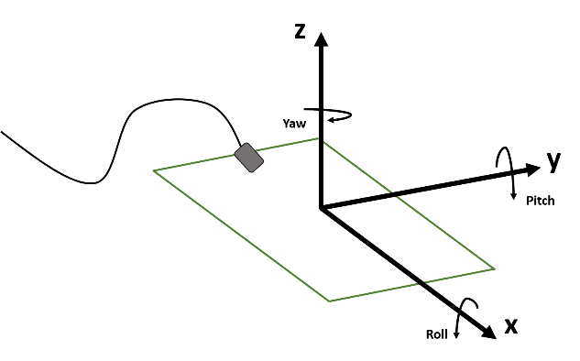

Figure 1: Board Axes and Tilt

### 3.1.2. Acceleration

--- How the angle is quantified

## 3.2. Data Calibration and Filtering

--- When data ready (signaled by an interrupt flag), perform calibration

### 3.2.1. Data Calibration

--- 6 positions expected (not normalized?) acceleration (0 0 1, 0 0 -1, 0 1 0, 0 -1 0, 1 0 0, -1 0 0)

--- Calibration operation (need equation)

### 3.2.2. Data Filtering

--- Kalman filter (what’s the purpose of filtering?)

### 3.2.3. Data Interpretation

--- Normalize acceleration

--- Convert from acceleration to angle in radian (need equation)

--- Alternative way of getting the angle (lookup table)

## 3.3. External Keypad

### 3.3.1. Circuit Layout

The keypad used for this experiment is composed of four columns and four rows. The pin associated to each of the columns and rows where experimentally found using a multimeter. Each pin on the keypad is connected to a column or a row. When a key is pressed, a connection is made between a column and a row. Therefore, we expected each pin to be disconnected when no key is pressed, and two pins to be shorted together when a key is pressed. Using a multimeter, we found the pair of pins associated to the pressing of each key. The results are illustrated in Figure 2. The first four pins were connected to the columns from left to right respectively. The last four pins were connected to the rows from up to down respectively.

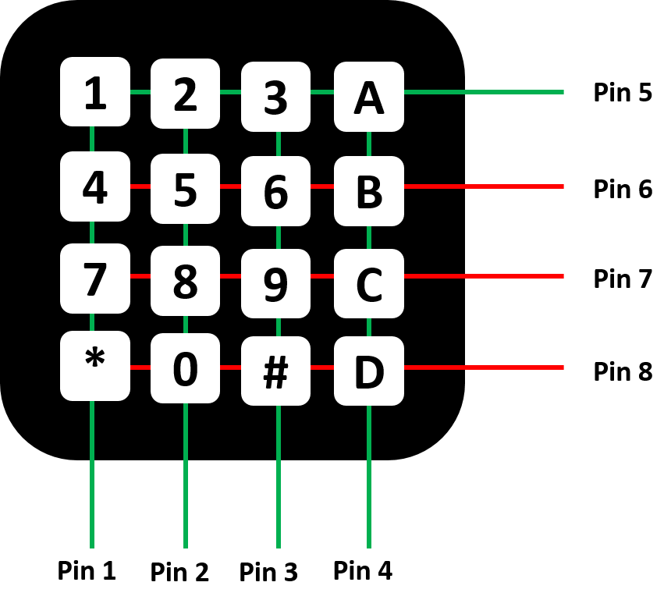

Figure : Keypad Layout

### 3.3.2. Data Acquisition

In order to know which pin is pressed, a scanning mechanism can be used. The first step is to find the row on which a pressed key located by setting the column pins high and watching the row pins. When no key is pressed, all row pins will remain unaffected. To achieve better result and avoid undefined states, the row pins can be pulled down. Once a key is pressed, a connection will be made between its corresponding row and column. By watching the change in voltage on the row pins, one can find the row corresponding to the pressed key. Figure 2 shows this step, where the column pins (pin 1 to 4) are set high (green) and when any key in the first row is pressed, pin 5 is set high (turn green). For pin 6, if its value toggled from low to high, a button is pressed on the second row. Similarly, the other rows can be determined in the same manner. The second step is to determine the column on which the key is located by setting the row pins high and watching the column similarly to the first step. Since the coordinates and the keys are mapped one to one, by knowing the row and column, the pressed key can be resolved. This methodology is only valid under the assumption that a single key is pressed at any time. If more than one key is pressed, the result will depend on the order in which rows and columns are scanned.

### 3.3.3. Handling Key Bouncing

The frequency at which the pins are scanned will affect the values read. If the scanning rate is much higher than the speed a user can input, the same input will be captured multiple times. To handle such situation, we can simply ignore consecutive identical inputs. However, an issue arises when user willingly inputs two identical values consecutively. To resolve that issue, a NO_INPUT signal can be introduced to catch the time when the key is released. The duration of the NO_INPUT must be defined to handle key bouncing, where the connection opens up without the user releasing the key. A NO_INPUT signal is considered as valid only after is has been observed for long enough.

## 3.4. External 7-Segment Display

### 3.4.1. Circuit Layout

The 7-segment display used for this experiment is composed of four digits, colon symbol after the second digit and degree symbol after the third digit. Each digit is composed of seven segments and a decimal point. The signal lines for the segments and the decimal point are shared between the digits. In order to control which digit should be updated, a select line is used for each of them. Similarly, there is a select line for the colon and the degree symbol. The colon symbol was not used in this experiment, therefore will be omitted from now on. As shown in Figure 3, the pins from the display cannot be directly connected to the board. For the segment pins, a resistor must be inserted to reduce the voltage at the input. The select pins must be controlled through the mean of a transistor. The transistor acts as a switch, when turned on, the select pin is connected to ground. To keep the Figure 3 concise, only one resistor and one transistor are shown.

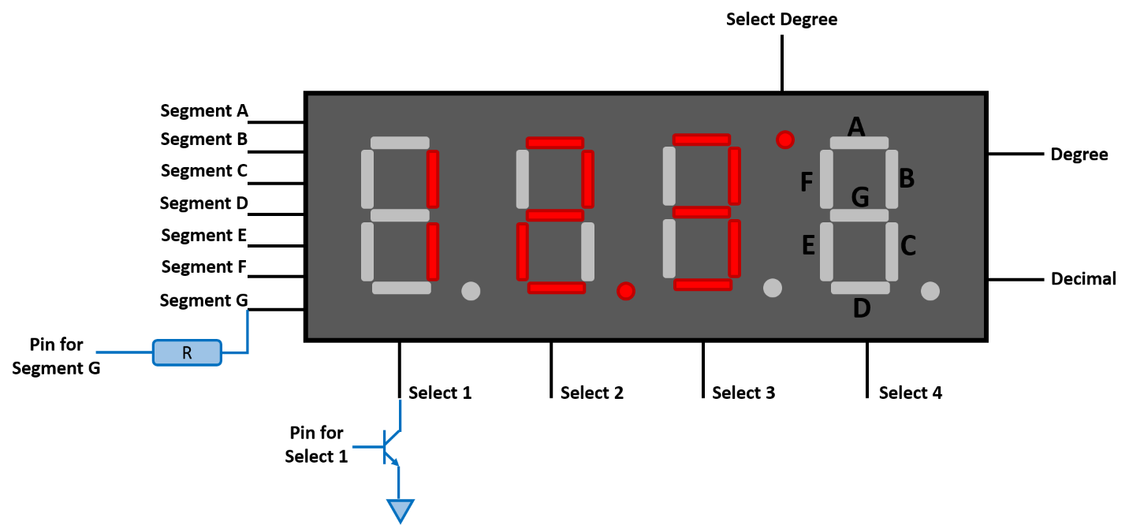

Figure 3: 7-Segment Display Layout

### 3.4.2. Data Display

As mentioned earlier, only one digit can be displayed at a time. To achieve the effect of all digits being turned on, the digits need to be refreshed quickly so the user will not see the flickering effect. To display values on a given digit, the corresponding select pin must be grounded by turning the transistor on. Once the digit is selected, the segments can be turned on to display the desired pattern. The segments must be held on for a given time period before releasing it and moving on to the next digit. If this time period is too short, the light will be faint. On the other hand, if this period is too long, there might not be enough time to refresh the digits before the flickering effect becomes noticeable. The timing of the 7-segment display can be determined experimentally with various frequencies.

## 3.5. Timing

### 3.5.1. Timing Based on Sample Rate

--- Interrupt when sample is ready

### 3.5.2. Timing Based on Hardware Timer

As mentioned in the External 7-Segment Display section, timing is important when displaying the digits. The segments must be kept on long enough to be visible without flickering. A hardware timer can be used for this purpose. The STM32F4 Discovery board is equipped with several timers operating at different maximum frequencies. Timer 3 (TIM3) used in this experiment has a bus frequency of 42 MHz. A prescaler is used to divide the frequency in to a counter frequency according to Eq.

$C_{freq}=\frac{Bus_{freq}}{prescaler}$ (Eq. )

When the timer uses a count up counter, the counter value is incremented at each prescaler period up to a maximum. When the counter has reached the maximum value, it is reset to zero and an interrupt flag is raised. The frequency of the flag is found using Eq.

$Interrupt_{freq}=\frac{C_{freq}}{{Counter}_{max}}=\frac{Bus_{freq}}{prescaler×{Counter}_{max}}$ (Eq. )

The waveforms of the different signals are shown in Figure 4.

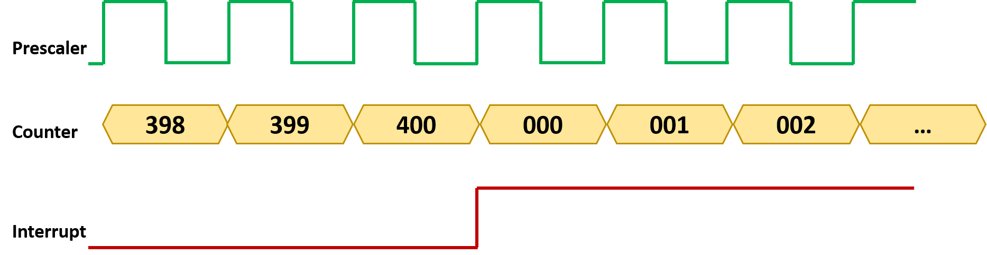

Figure 4: Timer Waveform

# 4. Implementation

The implementation of the system used the STM32F4 Discovery board, an external keypad and an external 7-segment display. The sections are presented in the order of which functions are called.

## 4.1. Component Configuration and Initialization

### 4.1.1. GPIO Configuration

The first step in this program is to configure and initialize the different GPIO ports. The on board accelerometer communicates through pin PE0. This pin is therefore set to take input. The 7-segment display is an external device, it must use free ports. These ports are selected and set as output ports. The on board LEDs communicate through ports PD12, PD13, PD14 and PD15. These ports are also set to be output ports. The keypad used to take user input also uses the free GPIO pins, however they cannot be configured and initialized here, because they change back and forth between an input and an output port. They will be configured based on their use.

### 4.1.2. Accelerometer Configuration, Accelerometer Interrupt and Interrupt Handler

--- Pin and channel

--- Frequency of the interrupt

### 4.1.3. Timer Configuration, Timer Interrupt and Interrupt Handler

A hardware timer is used to manage the timing at which the 7-segment display is updated. TIM3 is configured to use a prescaler of 1000 and count up to 400. According to Eq., this results in an interrupt frequency of 105Hz. These values were experimentally determined to avoid flickering effect while having reasonable intensity coming from the segments. The interrupt handle was designed to update to variables, the interrupt flag and the interrupt count. The interrupt flag determines when a digit on the 7-segment display should be updated. The interrupt count defines which digit to update. At every interrupt only one digit is updated; therefore, it takes four interrupts (three for the digits and one for degree symbol) to fully update the display.

## 4.2. Collect User Input

### 4.2.1. Initialize Keypad

As explained in the theory section, the keypad pins are used as both input and output. For this reason, they are configured on the go. After initializing the pins, the column pins are configured to be output pins and are set high whereas the row pins are configured to be input pins and are pulled down. The configuration is reversed for every read. Digits were constantly read and repeated values were omitted. The key bouncing problem is handled by ignoring sudden changes. For example, if NO_INPUT signal was detect for the first time, it might be due to key bouncing. Only after NO_INPUT signal was detected five consecutive times, the program can safely assume that the user has released the key and the missing signal was not due to a hardware bouncing.

### 4.2.2. Return User Input

For this experiment, users are expected to enter a value followed by the ENTER key. Since there were no key dedicated for this purpose, we used the pound key. When the ENTER key is pressed the result is scaled and returned to the processor. The scaling is necessary because the user have the liberty of entering one, two or three digits. The first digit entered is considered to be the most significant digit (the hundreds), while the third digit entered is considered to be the least significant digit (the ones). When user only enters one digit, it must be scaled to the ones and fill the other to digits with zero. Similarly, when user only enters two digits, they must be scaled to the tens and the ones.

### 4.2.3. Improvement on Keypad

Although the current implementation is functional and meet the requirements, some improvements could be added for the future. First, when the keypad function is called it only exits when ENTER is pressed. It is fine for the current implementation because the processor does not have other tasks to perform in the meantime and can wait after the keypad. To make the program more efficient, the execution should return to the main process and check the keypad status periodically. Second, the current implementation does not allow user to erase their inputs. The program must start over is the user has entered an erroneous value. A key could be dedicated to act like a BACKSPACE key.

## 4.3. Data Sampling

--- Continuous sampling

--- Signal processor when data is ready

## 4.4. Data Processing

--- Show calibration data in **Appendix A**

--- Kalman parameters, show Matlab simulation results in **Appendix B**

## 4.5. Data Comparison

---

## 4.6. Result Display

### 4.6.1. Visual Feedback

After comparing the current orientation against the targeted angle

--- Animation to direct user to move in the right direction

### 4.6.2. Display Current Angle

--- Only displaying the beta angle

## 4.7 Continuous Process

--- Continuous process until user presses reset

# 5. Testing and Observation

## 5.1. Accelerometer Calibration

--- Within 4 degree accuracy

--- Low accuracy, therefore could use lookup table instead

--- Using complex math functions on floating points --- more power hungry

--- Using lookup table --- less accurate --- more memory needed --- less power

## 5.2. Kalman Filter

--- Choice of constants

# 6. Conclusion

# Reference

# Appendix A – Calibration Data